Harsh Patel

hpatel90

Manual Test Plan 3

1. Determine that vehicles do not intersect at intersections.
2. Determine that vehicles do not run into each other when one is following another
3. Determine that vehicles stop for pedestrians that cross the street.



1. Determine that scrolling (on PC) and pinching (on mobile) zooms the device.
   1. Zoom out as far as possible
   2. Place finger or mouse on a location on the map.
   3. Drag around all four sides of the screen.
   4. Ensure that location on map stays beneath mouse/finger.
   5. Repeat again for medium zoom and full zoom.
2. Ensure that the quick view menu displays Increment and Transfer to Storage buttons for production tiles
   1. Select a production tile
   2. Ensure displays Increment and Transfer to Storage buttons are displayed.
   3. Repeat for all production tiles.
   4. Select a non-production tile
   5. Ensure Increment and Transfer to Storage buttons are not displayed.
3. Ensure production tiles display animation of production.
   1. Observe a production tile.
   2. Observe that the proper animation to display that product is being made plays when there is capacity in the production tile.

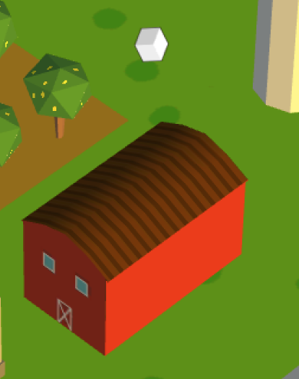

* 1. Observe that the animation stops after the capacity has been reached.
  2. Ensure the animation plays when the Increment button is pressed in the Quick View menu and there exists capacity.